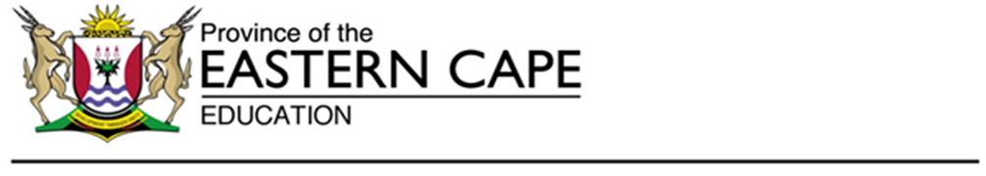
Examinations and Assessment Directorate
Steve Vukile Tshwete Complex, Zwelistsha, 5608
REPUBLIC OF SOUTH AFRICA, Website: www.ecdoe.gov.za
E-mail:Nomvuyo.Mbeleki@ecdoe.gov.za
Ref. No. | 13/P | Tel.: | (040) 608 7028/082 391 1342
Enquiries: | Ms N. Mbeleki | Fax:

TO: | DISTRICTS HEADS OF EXAMINATIONS  PRINCIPALS OF SCHOOLS IN THE FET BAND
FROM: | CES: INSTRUMENT DEVELOPMENT AND MODERATION SECTION
 | MS N. MBELEKI
SUBJECT: | ERRATA – MECHANICAL TECHNOLOGY – WELDING GRADE 12 (SEPTEMBER 2020)
DATE: | 14 OCTOBER 2020
The Mechanical Technology – Welding paper was written on the 01 October 2020. We were made aware of certain errors and omissions that were discovered during the marking process.

In order to address this and to ensure that learners are not disadvantaged, the following standardised approach to marking must be adopted across the Province. The following guidelines with regard to marking was prepared in conjunction with the examiner and moderator.
ERRATA
MECHANICAL TECHNOLOGY – WELDING

QUESTION | COMMENT
QUESTION 7 | 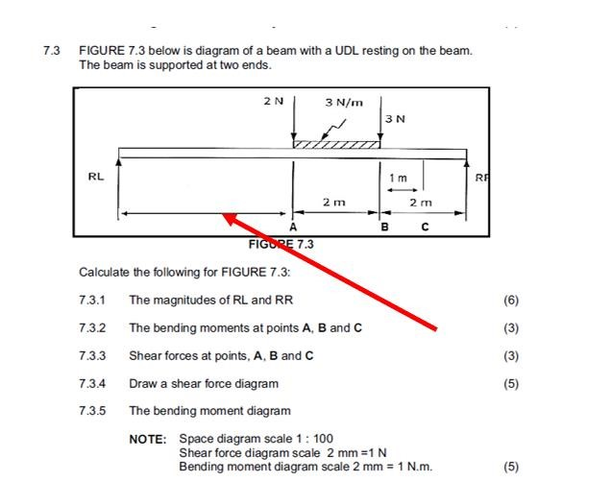  The dimension indicated by the red arrow above was missing, which affects the whole question and the sub- questions to question 7.3

QUESTION 11 | 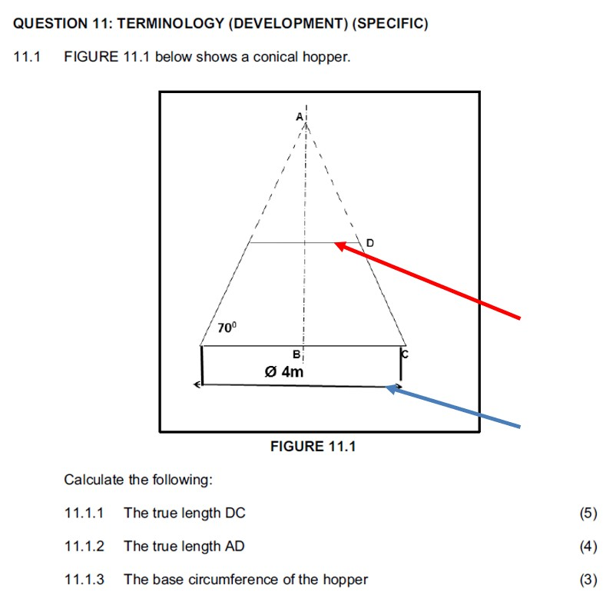  The red arrow indicates line D, which has no dimension and after calculations the length of line D will equals the dimension indicated by the blue arrow above and this might have confused many learners.

QUESTION 11 | 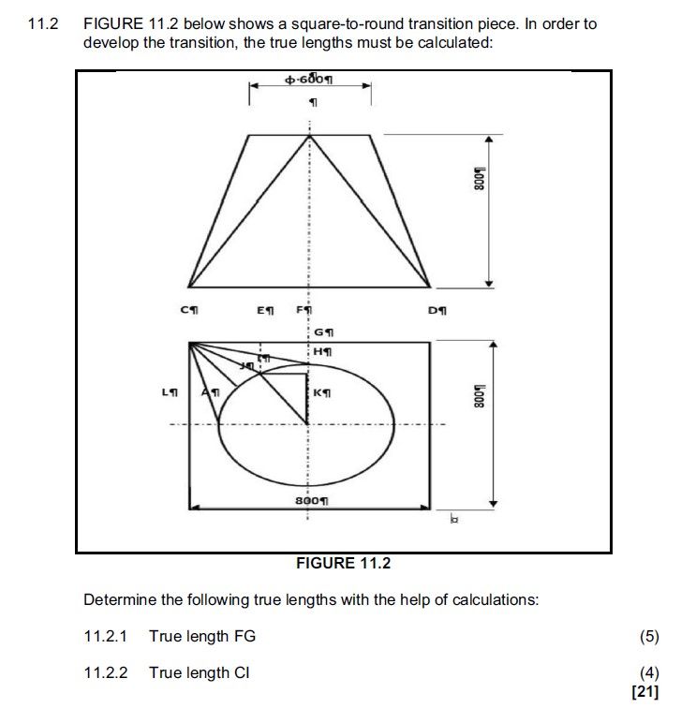
 | With reference to 11.2 above the formatting symbol is showing on the paper interfering with the dimensions provided meaning that some learners might have not seen the dimensions clearly which resulted in them using incorrect dimensions and this might have hindered their performance.
It is therefore suggested that the paper be marked out of 160 marks and the final mark of the candidate be converted to 200 marks

We request that this must be brought to the attention of all educators marking these papers and sincerely apologise for the inconvenience.
Yours in education.
 |  | 14 October 2020
MS N. MBELEKI |  | DATE

